**RESUME**

**M.ESAKKIAMMAL,**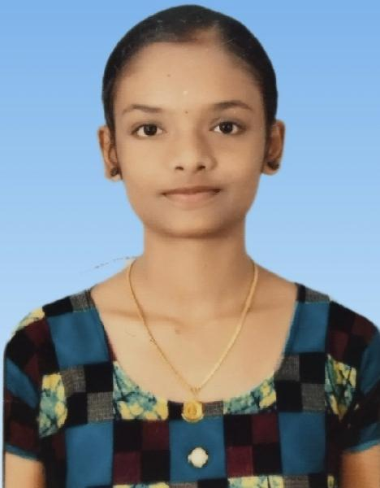

**D\o S. MELAVASAGAM,**

10/12/20,THIRAVIYA NAGAR,

SURANDAI,

V. K.PUDHUR(TK),

TENKASI(DIST)627811.

EMAIL ID : rakila287@gmail.com

MOBILE NUMBER : 9025086727/9843129625

**OBJECTIVE:**

Seeking a challenging position in a reputed organization where I can learn new skills,expand my knowledge, and leverage my Learnings.

**EDUCATIONAL CREDENTIALS**:

* SSLC 77.4% (2019)
* HSC 84.821(2021)
* Bachelor of Computer science(2nd year)

(Government Arts and Science College for Women,

Alangulam)

* Type : English Higher &Lower
* Course : Diploma in Microsoft Office (DMO)

**KEY STRENGTH:**

* Improving own learning and performance.
* Good Communication Skill.
* Flexibility in Adapting New Things.
* Good Creative Skill.

**PERSONAL DETAILS:**

Father’s Name : S. Melavasagam

Date of birth : 13th June 2004

Gender : Female

Marital Status : Unmarried

Nationality : Indian

Religion : Hindu

Language known : Tamil & English

**DECLARATION:**

I hereby declare that all the details given below are true to the best of my Knowledge and belief.

Place : Surandai Signature

Date : 10th April 2023 (Esakkiammal.M)